**WT LAB**

**NAME - Aniket Chatterjee**

**Roll No - 2005783**

**Section - CSE26**

**LAB-3**

**DATE-03/02/2022**

**Exp 1. Program to print your name, roll no, section and branch in separate lines.**

**CODE--**

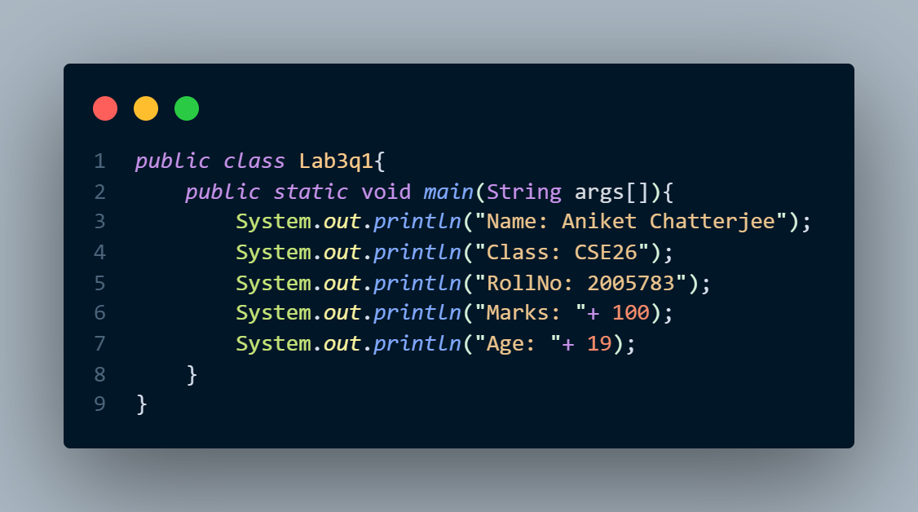

**OUTPUT--**

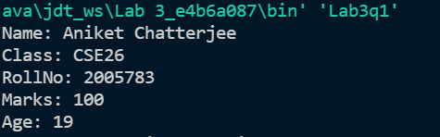

**Exp 2. Write a program in Java to take first name and last name from user and print both in one line as last name followed by first name.**

**CODE--**

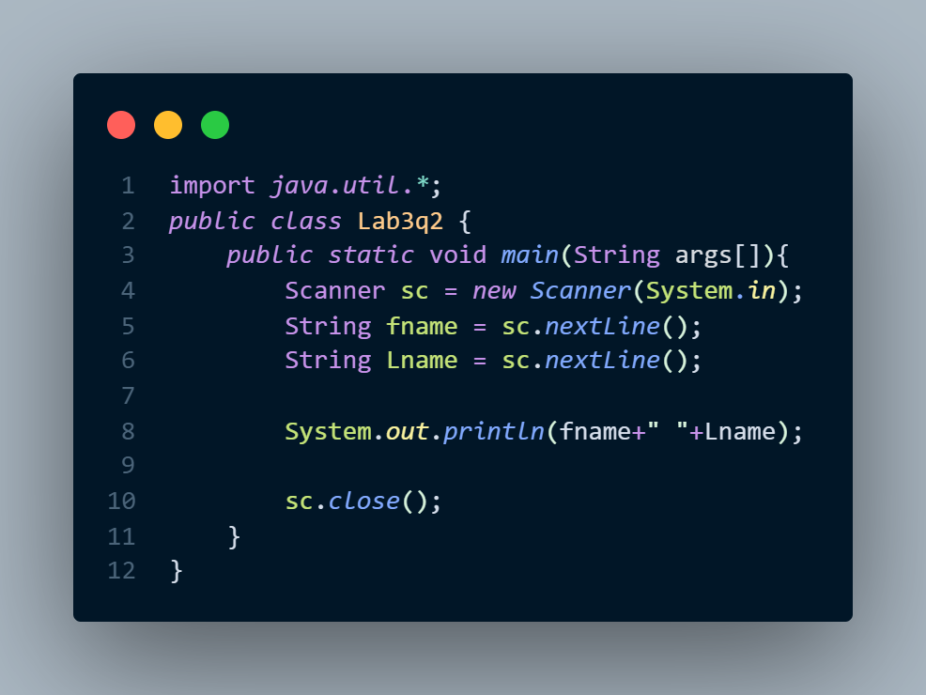

**OUTPUT--**

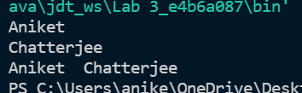

**Exp 3. Make program to makes a multiplication table as shown below.**

**1 2 3 4 5**

**2 4 6 8 10**

**3 6 9 12 15**

**4 8 12 16 20**

**CODE--**

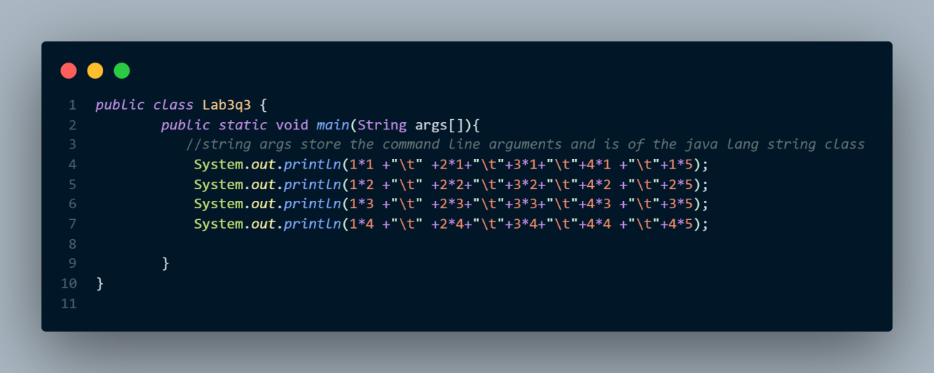

**OUTPUT--**

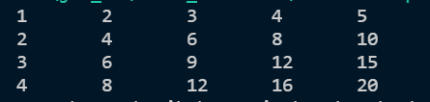

**Exp 4.- Write a program to generate a of random numbers between 1 and 6.**

**CODE--**

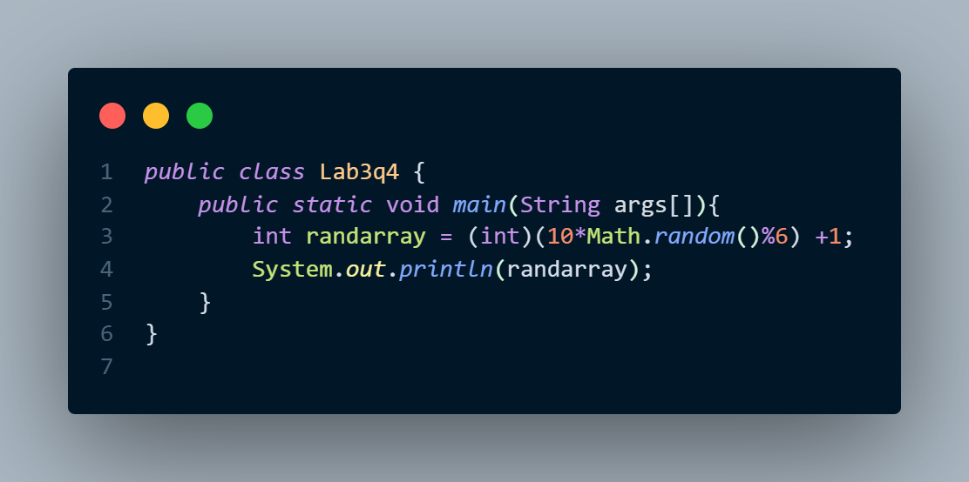

**OUTPUT--**



***-2005783***